**Serhii Holishevskyi**

Note: OY – always time  
OX – Time or array size

Time(ms) vs array size:

Combined:

Operations vs array size:

Combined:

**Binary search:**

Time(ms) vs array size:

Operations vs array size:

Program screenshot:

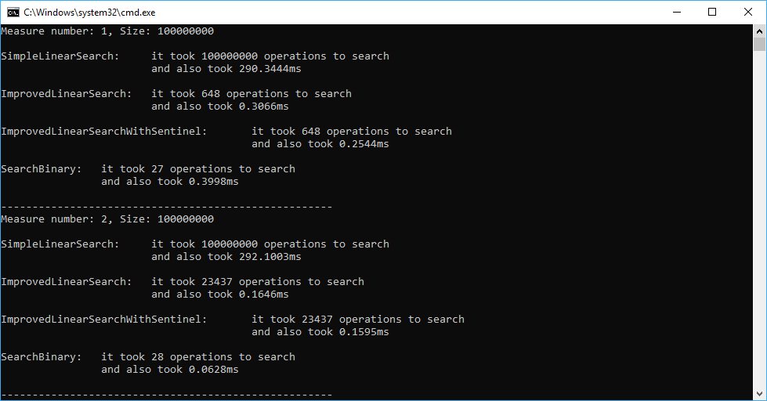

**Conclusion**: We worked with 4 search algorithms and it is obvious that LinearSearch algorithm is the worst according to the data and graphs, complexity is always O(n) and it takes more time to search depending on the size of the array. Improved Linear search algorithms make the same amount of operations to find an element, but Improved linear search with sentinel works much faster. Binary Search wins here with complexity O(lg n) - the minimum number of operations, incredible speed comparing to linear search algorithms.